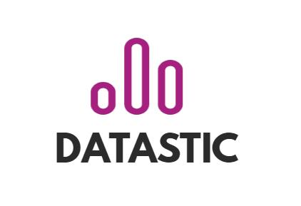

Flooid

Project plan



table of contents

1 Introduction 2

2 Context and background 3

3 Project definition 4

3.1 Project goal 4

3.2 Intended project result 4

3.3 Project prerequisites 4

3.4 Scope 4

3.4.1 Functional areas in scope 4

3.4.2 Community 5

3.4.3 Application scope 5

3.4.4 Data connections, migrations, rollouts 5

3.5 Research question 5

3.6 Plan of action 6

3.7 Deliverables 6

3.8 Product decomposition structure 6

4 Project management 7

4.1 Preconditions 7

4.2 Project organisation 7

4.3 Communication and consultation 7

4.4 Risk management 7

4.5 Global planning 9

4.6 Appendix 9

# Introduction

In the upcoming months until January, Datastic will help a start-up Flooid with a project. The project includes the creation of a prototype for a knowledge network, where parties like Fontys and Breda Universities of Applied Sciences, Tilburg University and Mindlabs will be available to find information using a web interface supported by the Natural Language Programming concept. To start this research, a project plan must be drawn up. That plan is described in this document. The plan starts with background information about Flooid and the current situation. After that, the project is defined by means of a goal, intended result, the scope, research questions and the approach with the accompanying deliverables like a business plan.

# Context and background

Flooid is a start-up company that mainly functions as a consulting partner in the networking industry with platforms using natural language processing and knowledge graphs. Flooid acts as a catalyst in the shift of systems creating impact in how people work, live and care for our environment. Their sense making indicates that many systems have reached their highest potential in relation to their context and need to shift. They do this by bringing people, knowledge and artificial intelligence together augmenting human capabilities, seamlessly integrating on- and offline worlds.

Flooid has its very roots in learning about reinventing organizations through communities. It has been the cradle for a model of community-based learning and innovation supported by a platform using the Natural Language Processing concept. Creating contexts for making explicit what is implicitly known resulting in collective learning Flooid has a list of partner universities and mindlabs that are ready to be a part of the networking environment (Annex).

The main idea of this network is to share partner’s knowledge and connect people to work together based on needed skills with a help of neo4j graph data platform. This network is also supposed to prevent time-wasting problems while two or more parties are working on similar projects apart. The network will be designed with the help of Flooid’s partner EyeOnText, that provides workshops on the Wowool SDK. It is a cross-platform tool and comes with language bindings for Python, C++. This tool helps to Ingest unstructured textual data and deliver structured semantic objects, such as entities, sentiments, profiles, facts and links.

# Project definition

## Project goal

In the period of September until January, a Proof of Concept of information network will be created. This network will connect all the partners that are listed within Appendix 1. With the network everyone in the community can see which information is already available.

## Intended project result

At the end of the project, the intended project result is a Proof of Concept of an information network that the community can and wants to use. In addition to the proof of concept, there will be a Business Plan created.

## Project prerequisites

Aa far as our team is not familiar with EyeOnText, NLP and Neo4j technologies, we need to explore these tools. For the NLP technology and “EyeOnText” environment, there will be training available for the company. Meaning that every employee will have knowledge about Natural Language Processing basic principles and how to apply these principles in practice in “EyeOnText” environment.

“Neo4j” graph data platform provides learning materials on its website. In order to learn how to work in the above-mentioned platform the “Neo4j” blog, videos, books and resource library will be studied.

Further to start the project we need first data, which we will gather from Flooid partners. To do this a meeting with some partner will be organised by Flooid.

## Scope

### Functional areas in scope

There are a lot of functional areas that might be important in later development of the project rather than the initial phase and creation of it.

Key functional areas in the current scope of the project would be:

* **Documentation.** During the project’s lifespan, the Datastic company will provide project owners with Project Plan and Business Plan where the most important project’s aspects will be described.
* **Data aggregation.** Datastic will aggregate data from open sources of the community using modern data gathering techniques and web scraping tools.
* **Natural Language Processing.** In order to create the network the data will be processed using the machine learning and Natura language processing technique**.**
* **Prototyping.** In order to test the quality of work, several prototypes of the final solution will be delivered. Each prototype version will be delivered to obtain feedback for future changes**.**
* **Obtaining customer’s feedback.** End users’ feedback is very important for this project as this is a pioneering idea. According to customer feedback, the versions of the prototype will be tuned to achieve customer’s satisfaction**.**
* **Marketing.** During the development of the Business Plan, the marketing aspect will be investigated. The company will describe the business aspect of the project as well as create a business model of distribution

Functional areas out of the scope of the project would be:

* **Documentation in Dutch language.** All documentation will be provided in the English language since the company consists of experts from different countries.
* **Digital twin.** Datastic company will not engage in the development of the digital twin project.
* **Sales.** Datastic company will not provide sales and distribution of the final solution
* **Law**. Datastic company will not provide an investigation of law part of the project. However, the company will perform according to its moral and ethical vision.

### Community

The project's community consists of universities, mindlabs, partners, and junior partners. Some of the end users will be used latter on to obtain feedback on the prototype. More information can be found in the Appendix 1.

### Application scope

Several applications need to be taken care of for this project to be successful. Such as the EyeOnText programming environment which will help to analyse the text using Natural Language Processing (NLP). The network will be built using “Neo4j” graph data platform. Neo4j is a trusted and advanced tool to quickly built intelligent applications and machine learning workflows. Before the processing part of the project, the data needs to be aggregated. To do so, several applications will be used such as “WebScrapper.io” and “Beautiful soup”.

### Data connections, migrations, rollouts

The data can be collected from open sources e.g. websites of Flooid partners. In order to obtain data from open sources, several web scraping applications will be used. The obtained data will be then stored locally in employees' environments in CSV formats.

## Research question

Main question

How to design an information network to enable its’ members to increase transparency and data flow?

Sub questions

1. What kind of data should be in network?
2. What are the community's needs for the network?
3. How can Datastic make a network using the tools (web scrapping, NLP, graphs) that are chosen?
4. How can the data from network be stored?
5. How can the network be presented to the end-user?
6. How can this project be transformed to a business?

## Plan of action

|  |  |  |  |
| --- | --- | --- | --- |
| Sub question | Research strategy | Methods | How? |
| 1. What kind of data should be in network? | * Library * Workshop | * Library research * Available product analysis * Brainstorm | * Investigating existing data sources * Research on other data sources |
| 1. What are the community's needs for the network? | * Library * Field | * Library research * Interview/survey | * Explore user requirements/needs * Analyse the most viable options * MoSCoW analysis * Requirement's prioritization |
| 1. How can Datastic make a network using the tools that are chosen? | * Workshop * Library | * Best good & bad practices * Library research * Expert interview | * Searching the web for existing solutions * Consult with the experts of the field |
| 1. How can the data from network be stored? | * Library * Workshop | * Field | * Explore available tools |
| 1. How can the network be presented to the end-user? | * Library * Workshop * Stepping Stones * Field | * Best, good & bad practices * Prototyping * Persona * Interview | * Search for examples of networks * Make a Prototype to present to the community and ask for feedback |
| 1. How can this project be transformed to a business? | * Stepping Stones | * Business Model Canvas | * Business plan |

## Deliverables

* Proof of Concept Network - prototype(s)
* Business Plan
* Project Plan

A project plan is essential at the start of every project. It serves as the foundation for the entire project, establishing rules for the entire duration of work. It also includes some of the most important parts, such as a plan of action, an explanation of the deliverables, a project goal, various analyses, and so on - all the activities, tasks, and resources that will be used to complete the project.

During the later phases of the project the business plan will be developed. This includes way of distributing of the product.

## Product decomposition structure

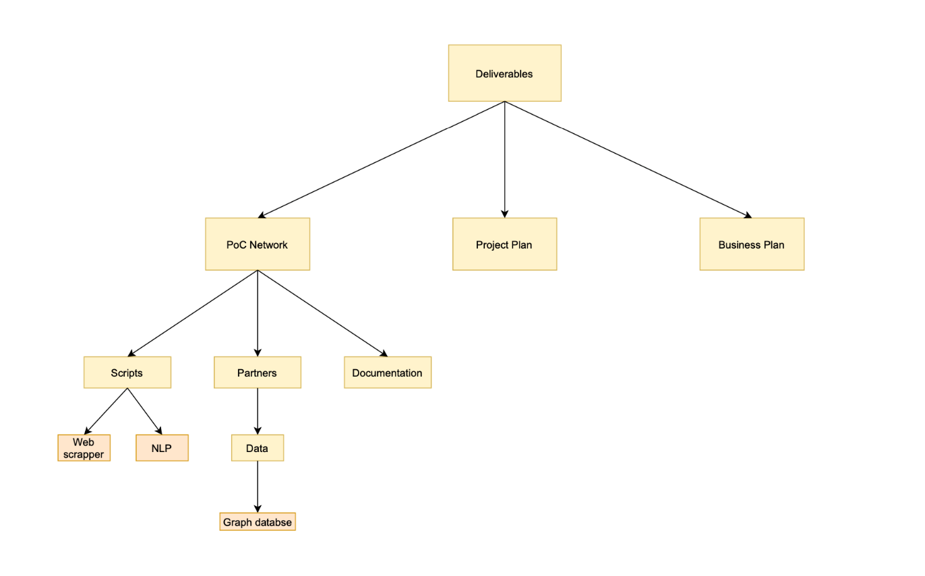

# Project management

## Preconditions

Predicates that must always be true prior to the execution of the project:

1. Team members have a broad idea of the project’s scope
2. Team members have defined roles within the company
3. Team members and stakeholders plan achievable goals in the given timeframe
4. Team members and stakeholders are aware of the project risks and constraints

## Project organisation

|  |  |
| --- | --- |
| **Student** | **Role** |
| Stefan Groenendal | Project Owner |
| Rene Katerberg | Project Owner |
| Nikita Gavrilov | Project Leader |
| Ilya Tsakunov | Note Taker |
| Sasha Vereshchagin | Chairman |
| Victor Plesciuc | Team Member |
| Remco Bisschops | Team Member |
| Yaniek Martens | Team Member |
| Lieke Nijs | Team Member |
| Femke Boogerd | Team Member |
| Gergana Agorasteva | Team Member |

Project Leader - manages the team, makes sure the deadlines are met and the deliverables are sufficient

Chairman – meeting coordinator, spokesperson for the group

Note Taker – takes organized, legible and typed notes every meeting

## Communication and consultation

The communication between Flooid and Datastic will be made mainly through WhatsApp and Zoom. Physical meetings will only be arranged if the safety COVID-19 measures are properly met.

**Meetings planning**

Recurring Zoom meetings will take place every Monday at 14:30.

## Risk management

This chapter is devoted to Risk Management. In context of this project, we assigned 6 risk categories. 5 of them went from the PESTLE Analysis. PESTLE stands for Political, Economic, Social, Technological, Legal and Environmental factors. This analysis allows to form an impression of the factors that might impact the product. One of the elements (environmental risk) was replaced with financial category as non-relevant for this project.

|  |  |
| --- | --- |
| Category | |
| P | Politic |
| E | Economic |
| S | Social |
| T | Technological |
| L | Legal |
| F | Financial |

Typical Risk Management is usually considered in 2 aspects: probability and impact. Both aspects were divided into 3 levels: Low, Medium, High.

|  |  |
| --- | --- |
| Probability | |
| L | Low |
| M | Medium |
| H | High |

|  |  |
| --- | --- |
| Impact | |
| L | Low |
| M | Medium |
| H | High |

For each risk probability and impact were identified and depending on these indicators risk level was determined.

|  |  |
| --- | --- |
| Risk Levels | |
| Low Probability X Low Impact | Low |
| Low Probability X Medium Impact | Low |
| Medium Probability X Low Impact | Low |
| Medium Probability X Medium Impact | Medium |
| Low Probability X High Impact | Medium |
| High Probability X Low Impact | Medium |
| Medium Probability X High Impact | High |
| High Probability X Medium Impact | High |
| High Probability X High Impact | High |

The most common ways of risk mitigation are shown in a table below.

|  |  |
| --- | --- |
| Risk Mitigation | |
| Av | Avoidance |
| Acc | Acceptation |
| S | Sharing |
| R | Reduction |
| T | Transfer |

Based on initial information about the project, the following risks were defined. The list below is not final and will be expanded as new information well be received.

|  |  |  |  |  |  |  |  |
| --- | --- | --- | --- | --- | --- | --- | --- |
| ID | Cat. | Risk | Prob. | Impact | Level | Mitigation | Actions |
| R1 | S | Sharing information | H | M | H | Acc | Arrange with partners |
| R2 | F | Lack of funds for development | M | M | M | Av | Make business plan |
| R3 | S | Getting out of project scope | L | M | M | S | Prioritization of tasks |
| R4 | S | The project team is not fully committed | L | L | L | Av | Clear division of responsibilities, regular progress checks |
| R5 | S | Misunderstanding within a team | L | L | L | Acc | Preparing questions, regular discussions |
| R6 | T | Lack of knowledge | M | H | H | R | Organise workshops, independent study of tools |
| R7 | S | Not meeting deadlines | M | M | M | Av | Prepare timeline of project, regular progress checks |

The first risk is related to adding to network such kind of information that the company do not really want to share. The second risk is from financial category. Flooid is initially a non-profit startup. However, further development of the project may require funds. This risk can be avoided with a well thought out business plan. Risk R4 comes out of the fact that each team member is working on 2 projects at the same time. R5 is low-level risk as well as R4. However, it cannot be omitted, otherwise it can slow down the development of the project. Risk R6 is one of the most important as tools we are going to use during the project are mostly unknown for us. A certain time is needed to explore them.

## Global planning

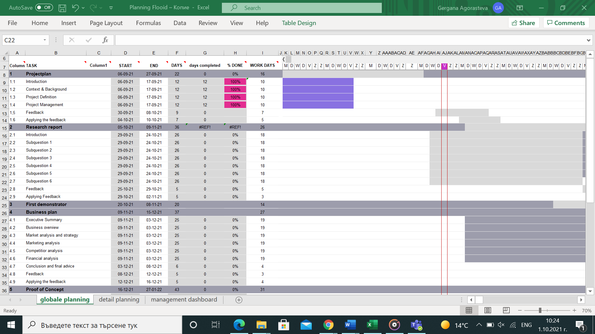

## Appendix

4.6.1 Community

Universities:

* Breda University of Applied Sciences
* Fontys
* Tilburg University

Mindlabs:

Partners:

* Mijzo
* WPG/Zwijsen
* Interpolis
* Thebe and De Wever

Junior Partners:

* Anyware
* Castlab
* Genius Voice
* Ivy Works
* Thoughtline
* Blewscreen
* Flow Concepts
* Hi Lex
* Purple Mountain

DigiShape:

* Rijkswaterstraat
* Deltares
* Van Oord
* TU Delft
* Boskalis
* BZ Ingenieurs & Managers
* Periplus Consultancy
* Marin
* HKV
* Witteveen Bos
* IHM
* Maris
* Port of Rotterdam